[741. Cherry Pickup](https://leetcode.com/problems/cherry-pickup/description/)

You are given an n x n grid representing a field of cherries, each cell is one of three possible integers.

* 0 means the cell is empty, so you can pass through,
* 1 means the cell contains a cherry that you can pick up and pass through, or
* -1 means the cell contains a thorn that blocks your way.

Return *the maximum number of cherries you can collect by following the rules below*:

* Starting at the position (0, 0) and reaching (n - 1, n - 1) by moving right or down through valid path cells (cells with value 0 or 1).
* After reaching (n - 1, n - 1), returning to (0, 0) by moving left or up through valid path cells.
* When passing through a path cell containing a cherry, you pick it up, and the cell becomes an empty cell 0.
* If there is no valid path between (0, 0) and (n - 1, n - 1), then no cherries can be collected.

**Example 1:**

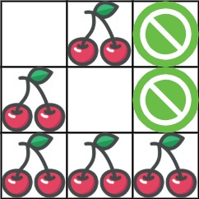

**Input:** grid = [[0,1,-1],[1,0,-1],[1,1,1]]

**Output:** 5

**Explanation:** The player started at (0, 0) and went down, down, right right to reach (2, 2).

4 cherries were picked up during this single trip, and the matrix becomes [[0,1,-1],[0,0,-1],[0,0,0]].

Then, the player went left, up, up, left to return home, picking up one more cherry.

The total number of cherries picked up is 5, and this is the maximum possible.

**Example 2:**

**Input:** grid = [[1,1,-1],[1,-1,1],[-1,1,1]]

**Output:** 0

**Constraints:**

* n == grid.length
* n == grid[i].length
* 1 <= n <= 50
* grid[i][j] is -1, 0, or 1.
* grid[0][0] != -1
* grid[n - 1][n - 1] != -1